**Forecasting – Plastic Sales**

Visualization show that Sales having level, trend and seasonality i.e. Additive Seasonality

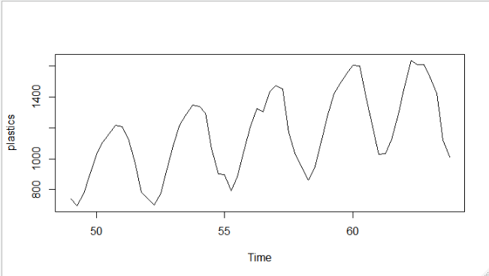

**Using HoltWinters Function 🡺**

**Optimum Values with alpha = 0.2 which is default value assuming time series data has only level parameter**

Alpha = level smoothing, Beta = Trend smoothing, Gama = Seasonality Smoothing

Smoothing parameters:

alpha: 0.2

beta : FALSE

gamma: FALSE

Coefficients:

[,1]

a 4222.86

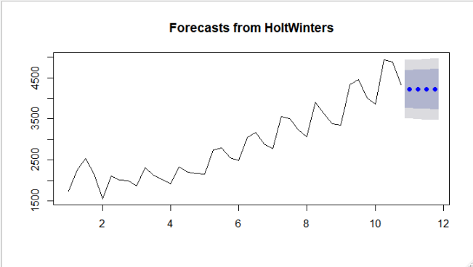

> hwa_mape

[1] 16.12634

**Optimum values with aplha =0.2, beta=0.1 assuming time series data has level and trend parameter**

Smoothing parameters:

alpha: 0.2

beta : 0.1

gamma: FALSE

Coefficients:

[,1]

a 4541.49927

b 94.23843

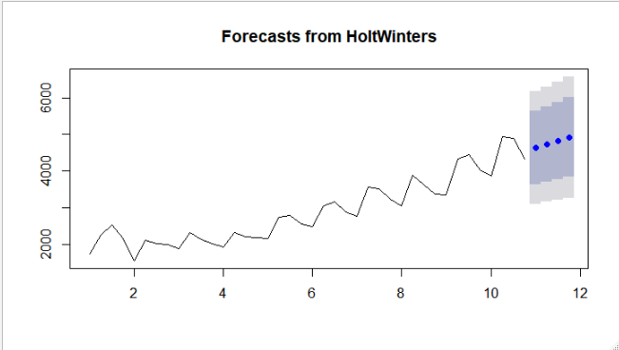

> hwab_mape

[1] 8.928085

**Optimum values with alpha =0.2, beta =0.1, gamma=0.1 assuming time series data has level, trend and seasonality**

Smoothing parameters:

alpha: 0.2

beta : 0.1

gamma: 0.1

Coefficients:

[,1]

a 4388.85411

b 98.81771

s1 -241.41753

s2 403.81657

s3 427.05132

s4 89.34998

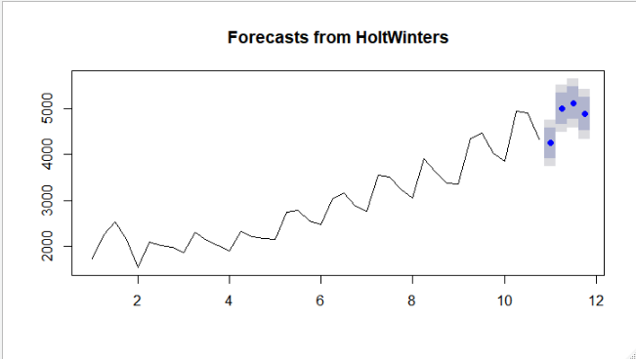

> hwabg_mape

[1] 8.928085

**By looking at the plot the characters of forecasted values are closely following historical data.**

**Without optimum values 🡺**

Smoothing parameters:

alpha: 0.5121267

beta : FALSE

gamma: FALSE

Coefficients:

[,1]

a 4505.092

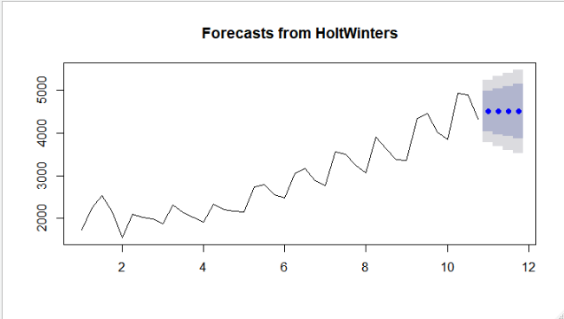

> hwna_mape

[1] 9.093032

Smoothing parameters:

alpha: 0.557324

beta : 0.3096004

gamma: FALSE

Coefficients:

[,1]

a 4644.30671

b 82.90134

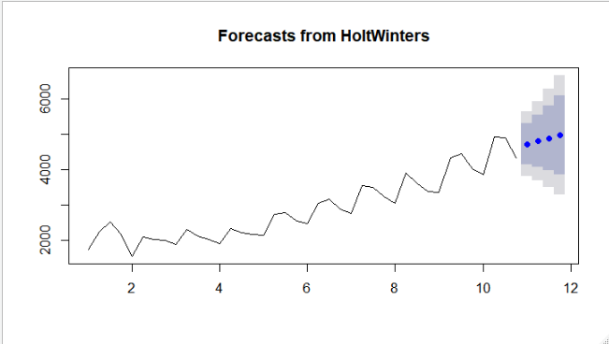

> hwnab_mape

[1] 8.627493

|  |
| --- |
| Smoothing parameters:  alpha: 0.3932448  beta : 0.2371347  gamma: 0.9592084  Coefficients:  [,1]  a 4376.52160  b 107.43863  s1 -193.78961  s2 755.41436  s3 592.07698  s4 -40.76381 |
|  |
| |  | | --- | | > hwnabg_mape  [1] 2.397212 | |

**By looking at the plot the characters of without optimum forecasted values are closely following historical data.**